Project Name :

A comprehensive Analysis of financial performance :Insights from a leading banks

Team members:

S. Shahina Banu

M. Amaravathi

R. Abinaya

M. Anitha

PROJECT REPORT

Introduction :

Financial performance analysis and interpretation of financial statement in such a ways that it undertakes full diagnosis of the profitability and financial soundness of a business . The financial analyst program provides vital methodologies of financial analysis. A , t analysis, in the fintuncial world refers to the complete analysis of every relevant aspects of a company financial operation.

**Result:**

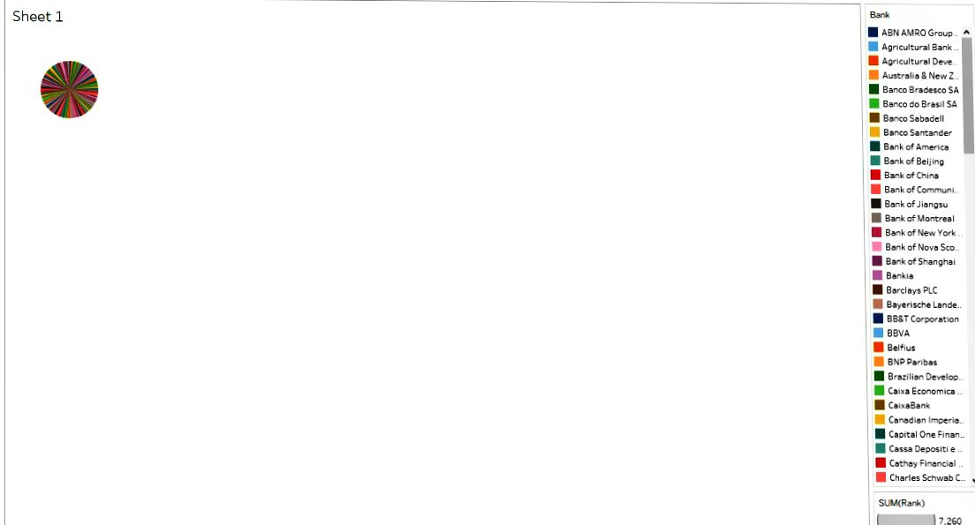

**Purpose:**

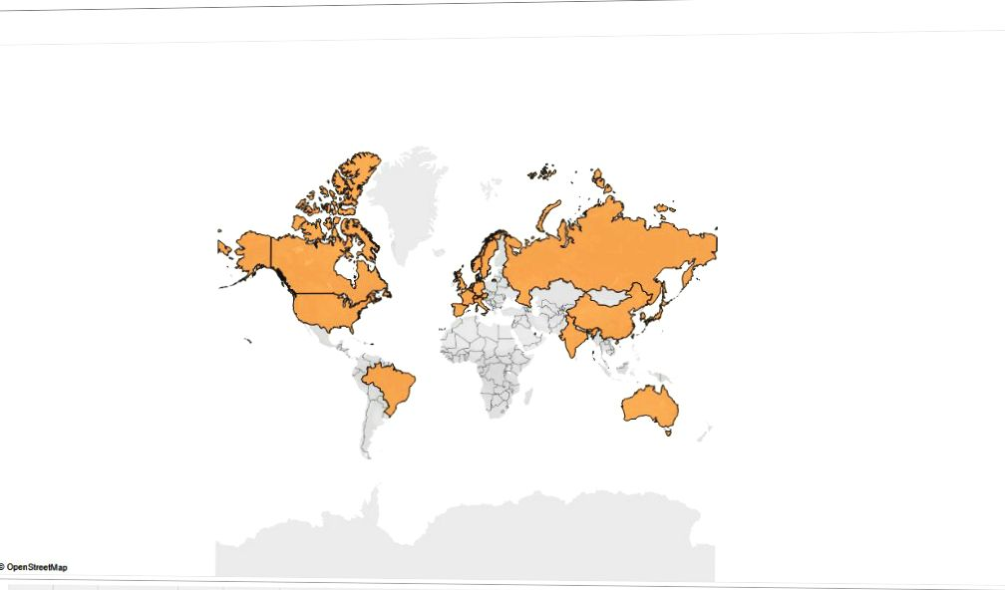  The main objective of financial analysis for a company is to provide necessary information required by financial statem3

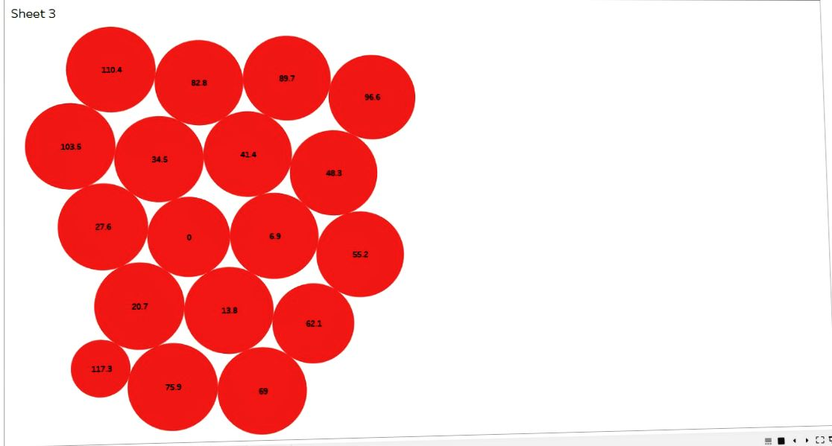Purpose:

To analysis whether an entity is stable, liquid, solvent, or profitable enough to warrant a

Application:

A banking app has to support transaction between user's own credit as well as between the user and a different account.

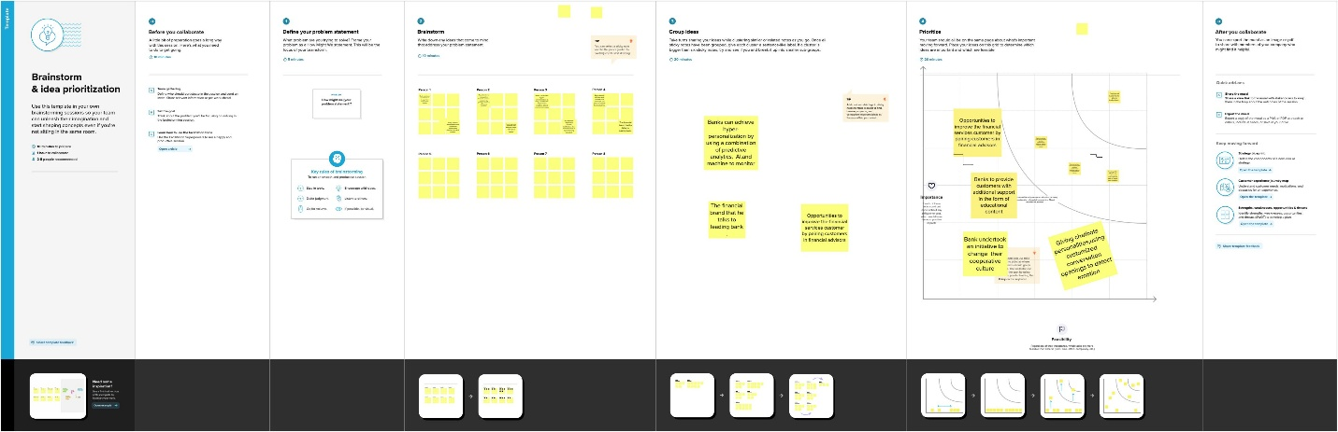

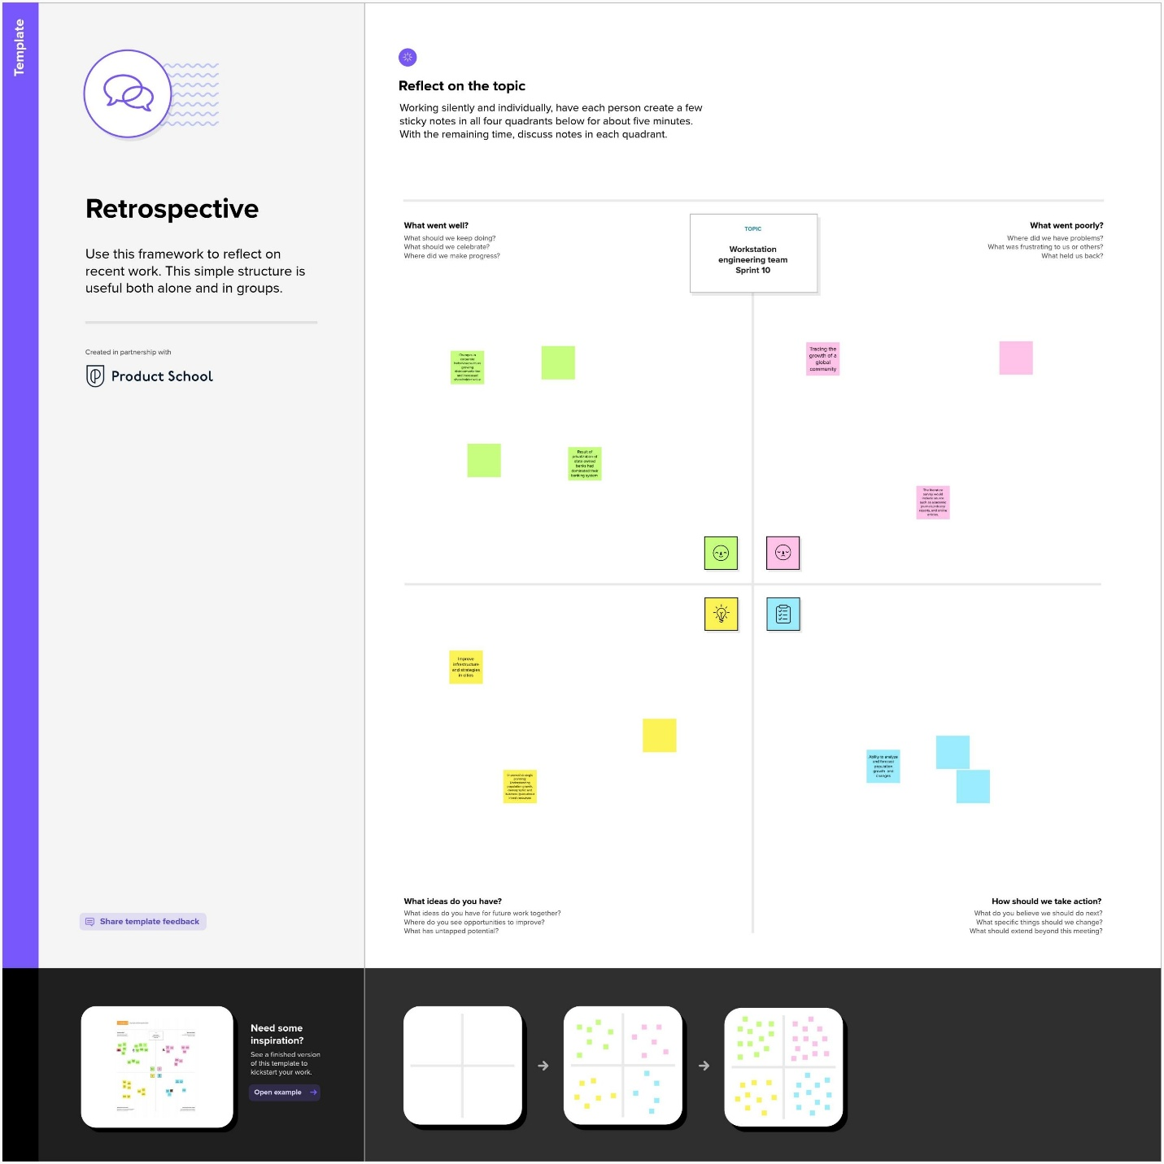

Application:

A user can send transaction to multiple users. They should only be able to do so if they have sufficient funds in their account balance.

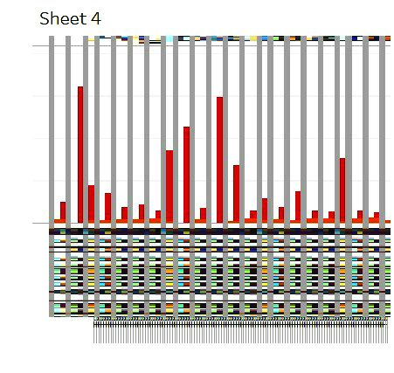 It provides a snapshot of a corporations financial health, giving inside into its performance, operations and cast flow.

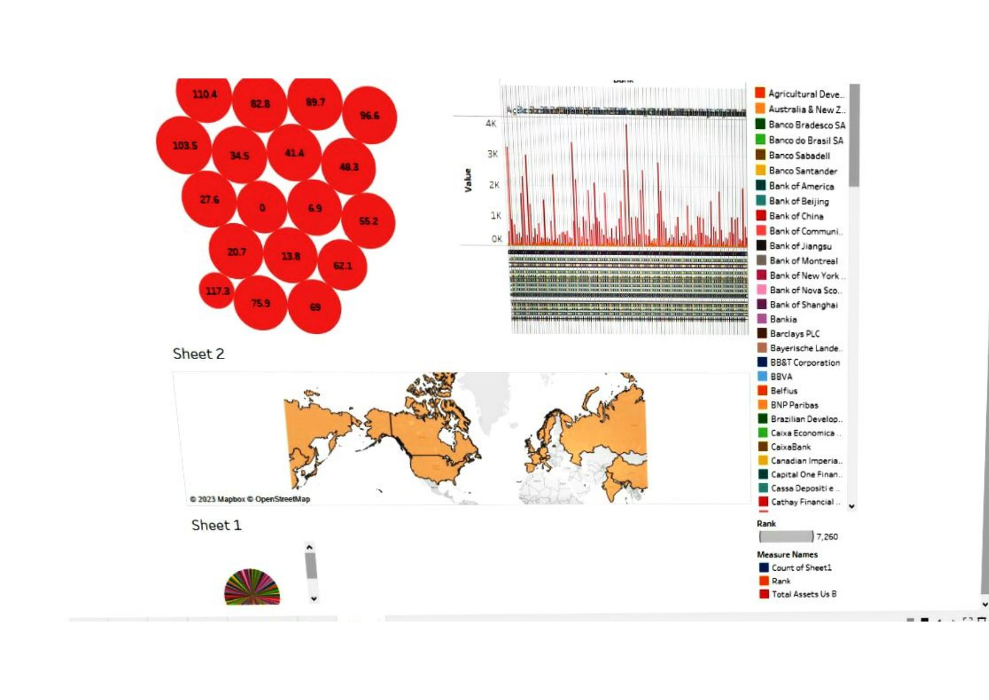

Disadvantage :

Regularly charge higher fees than smaller bank institution

Generally take longer to process loan applications

Uses:

It is used by internal and external stateholders to evaluate business performances and value.

Where project manager carry out the financial analysis they do so to ascertain whether a project will be a profitable under taking and would warrant financial invertment

Conclusion:

Analysis of financial statements is extremely important for every business to grow and increase their revenue.

Appendix:

Source Code:

<!DOCTYPE html>

<html lang="en">

<head>

  <meta charset="utf-8">

  <meta content="width=device-width, initial-scale=1.0" name="viewport">

  <title>Fin Analytica</title>

  <meta content="" name="description">

  <meta content="" name="keywords">

  <!-- Favicons -->

  <link href="assets/img/favicon.png" rel="icon">

  <link href="assets/img/apple-touch-icon.png" rel="apple-touch-icon">

  <!-- Google Fonts -->

  <link rel="preconnect" href="https://fonts.googleapis.com">

  <link rel="preconnect" href="https://fonts.gstatic.com" crossorigin>

  <link href="https://fonts.googleapis.com/css2?family=Open+Sans:ital,wght@0,300;0,400;0,500;0,600;0,700;1,300;1,400;1,600;1,700&family=Montserrat:ital,wght@0,300;0,400;0,500;0,600;0,700;1,300;1,400;1,500;1,600;1,700&family=Raleway:ital,wght@0,300;0,400;0,500;0,600;0,700;1,300;1,400;1,500;1,600;1,700&display=swap" rel="stylesheet">

  <!-- Vendor CSS Files -->

  <link href="assets/vendor/bootstrap/css/bootstrap.min.css" rel="stylesheet">

  <link href="assets/vendor/bootstrap-icons/bootstrap-icons.css" rel="stylesheet">

  <link href="assets/vendor/aos/aos.css" rel="stylesheet">

  <link href="assets/vendor/glightbox/css/glightbox.min.css" rel="stylesheet">

  <link href="assets/vendor/swiper/swiper-bundle.min.css" rel="stylesheet">

  <!-- Template Main CSS File -->

  <link href="assets/css/main.css" rel="stylesheet">

  <!-- =======================================================

  * Template Name: Impact - v1.1.1

  * Template URL: https://bootstrapmade.com/impact-bootstrap-business-website-template/

  * Author: BootstrapMade.com

  * License: https://bootstrapmade.com/license/

  ======================================================== -->

</head>

<body>

  <!-- ======= Header ======= -->

  <section id="topbar" class="topbar d-flex align-items-center">

    <div class="container d-flex justify-content-center justify-content-md-between">

      <div class="contact-info d-flex align-items-center">

        <i class="bi bi-envelope d-flex align-items-center"><a href="mailto:contact@example.com">finanalytica@gmail.com</a></i>

        <i class="bi bi-phone d-flex align-items-center ms-4"><span>+999999999</span></i>

      </div>

      <div class="social-links d-none d-md-flex align-items-center">

        <a href="#" class="twitter"><i class="bi bi-twitter"></i></a>

        <a href="#" class="facebook"><i class="bi bi-facebook"></i></a>

        <a href="#" class="instagram"><i class="bi bi-instagram"></i></a>

        <a href="#" class="linkedin"><i class="bi bi-linkedin"></i></i></a>

      </div>

    </div>

  </section><!-- End Top Bar -->

  <header id="header" class="header d-flex align-items-center">

    <div class="container-fluid container-xl d-flex align-items-center justify-content-between">

      <a href="index.html" class="logo d-flex align-items-center">

        <!-- Uncomment the line below if you also wish to use an image logo -->

        <!-- <img src="assets/img/logo.png" alt=""> -->

        <h1>Fin Analytica<span>.</span></h1>

      </a>

      <nav id="navbar" class="navbar">

        <ul>

          <li><a href="#hero">Home</a></li>

          <li><a href="#about">About</a></li>

          <li><a href="#portfolio">Dashboard</a></li>

          <li><a href="#team">Story</a></li>

          <li><a href="#contact">Contact</a></li>

        </ul>

      </nav><!-- .navbar -->

      <i class="mobile-nav-toggle mobile-nav-show bi bi-list"></i>

      <i class="mobile-nav-toggle mobile-nav-hide d-none bi bi-x"></i>

    </div>

  </header><!-- End Header -->

  <!-- End Header -->

  <!-- ======= Hero Section ======= -->

  <section id="hero" class="hero">

    <div class="container position-relative">

      <div class="row gy-5" data-aos="fade-in">

        <div class="col-lg-6 order-2 order-lg-1 d-flex flex-column justify-content-center text-center text-lg-start">

          <h2>Welcome to <span>Fin Analytica</span></h2>

          <p>A widely used approach to analyzing a bank, CAMELS, considers a bank's Capital adequacy, Asset quality, Management capabilities, Earnings sufficiency, Liquidity position, and Sensitivity to market risk..</p>

          <div class="d-flex justify-content-center justify-content-lg-start">

            <a href="#about" class="btn-get-started">Get Started</a>

            <a href="https://www.youtube.com/watch?v=fTTGALaRZoc" class="glightbox btn-watch-video d-flex align-items-center"><i class="bi bi-play-circle"></i><span>Watch Video</span></a>

          </div>

        </div>

        <div class="col-lg-6 order-1 order-lg-2">

          <img src="assets/img/200w.gif" class="img-fluid" alt="" data-aos="zoom-out" data-aos-delay="100">

        </div>

      </div>

    </div>

    <div class="icon-boxes position-relative">

      <div class="container position-relative">

        <div class="row gy-4 mt-5">

          <div class="col-xl-3 col-md-6" data-aos="fade-up" data-aos-delay="100">

            <div class="icon-box">

              <div class="icon"><i class="bi bi-card-text"></i></div>

              <h4 class="title"><a href="" class="stretched-link">Statiscal analysis</a></h4>

            </div>

          </div>

          <!--End Icon Box -->

          <div class="col-xl-3 col-md-6" data-aos="fade-up" data-aos-delay="200">

            <div class="icon-box">

              <div class="icon"><i class="bi bi-bar-chart"></i></div>

              <h4 class="title"><a href="" class="stretched-link">Data Visualization</a></h4>

            </div>

          </div>

          <!--End Icon Box -->

          <div class="col-xl-3 col-md-6" data-aos="fade-up" data-aos-delay="300">

            <div class="icon-box">

              <div class="icon"><i class="bi bi-laptop"></i></div>

              <h4 class="title"><a href="" class="stretched-link">Machine Learning</a></h4>

            </div>

          </div>

          <!--End Icon Box -->

          <div class="col-xl-3 col-md-6" data-aos="fade-up" data-aos-delay="500">

            <div class="icon-box">

              <div class="icon"><i class="bi bi-cpu"></i></div>

              <h4 class="title"><a href="" class="stretched-link">Artificial Intelligence</a></h4>

            </div>

          </div>

          <!--End Icon Box -->

        </div>

      </div>

    </div>

    </div>

  </section>

  <!-- End Hero Section -->

  <main id="main">

    <!-- ======= About Us Section ======= -->

    <section id="about" class="about">

      <div class="container" data-aos="fade-up">

        <div class="section-header">

          <h2>About Us</h2>

          <p>We provide best Business intelligence solutions to the companies,which makes a strategy for elevating their business in the market</p>

        </div>

        <div class="row gy-4">

          <div class="col-lg-6">

            <h3>Insight generations through sophasticated tools</h3>

            <img src="assets/img/about.jpg" class="img-fluid rounded-4 mb-4" alt="">

          </div>

          <div class="col-lg-6">

            <div class="content ps-0 ps-lg-5">

              <p class="fst-italic">

                We provide business solutions in various domains.

              </p>

              <ul>

                <li><i class="bi bi-check-circle-fill"></i> Insights generations using Business Intelligence.</li>

                <li><i class="bi bi-check-circle-fill"></i> Building Data models using Statistics.</li>

                <li><i class="bi bi-check-circle-fill"></i> Developing the predictive models.</li>

              </ul>

              <div class="position-relative mt-4">

                <img src="assets/img/about-2.jpg" class="img-fluid rounded-4" alt="">

                <a href="https://www.youtube.com/watch?v=LXb3EKWsInQ" class="glightbox play-btn"></a>

              </div>

            </div>

          </div>

        </div>

      </div>

    </section><!-- End About Us Section -->

    <!-- ======= Stats Counter Section ======= -->

    <section id="stats-counter" class="stats-counter">

      <div class="container" data-aos="fade-up">

        <div class="row gy-4 align-items-center">

          <div class="col-lg-6">

            <img src="assets/img/stats-img.svg" alt="" class="img-fluid">

          </div>

          <div class="col-lg-6">

            <div class="stats-item d-flex align-items-center">

              <span data-purecounter-start="0" data-purecounter-end="1000000" data-purecounter-duration="1" class="purecounter"></span>

              <p><strong>Students</strong> has Succesfully trained</p>

            </div><!-- End Stats Item -->

            <div class="stats-item d-flex align-items-center">

              <span data-purecounter-start="0" data-purecounter-end="300" data-purecounter-duration="1" class="purecounter"></span>

              <p><strong>Projects</strong> has been developed</p>

            </div><!-- End Stats Item -->

            <div class="stats-item d-flex align-items-center">

              <span data-purecounter-start="0" data-purecounter-end="10000" data-purecounter-duration="1" class="purecounter"></span>

              <p><strong>Hours Of Support</strong> has been delivered</p>

            </div><!-- End Stats Item -->

          </div>

        </div>

      </div>

    </section><!-- End Stats Counter Section -->

    <!-- ======= Call To Action Section ======= -->

    <section id="call-to-action" class="call-to-action">

      <div class="container text-center" data-aos="zoom-out">

        <a href="https://www.youtube.com/watch?v=To2nuBRP7fE" class="glightbox play-btn"></a>

        <h3>Call To Action</h3>

        <a class="cta-btn" href="#">Call To Action</a>

      </div>

    </section><!-- End Call To Action Section -->

    <!-- ======= Portfolio Section ======= -->

    <section id="portfolio" class="portfolio sections-bg">

      <div class="container" data-aos="fade-up">

        <div class="section-header">

          <h2>Insights</h2>

          f='#'><img al

          < <div class='tableauPlaceholder' id='viz1682429166382' style='position: relative'><noscript><a href='#'><img alt='Dashboard 1 ' src='https:&#47;&#47;public.tableau.com&#47;static&#47;images&#47;Ba&#47;BanuIIIMaths_16824290743380&#47;Dashboard1&#47;1_rss.png' style='border: none' /></a></noscript><object class='tableauViz'  style='display:none;'><param name='host_url' value='https%3A%2F%2Fpublic.tableau.com%2F' /> <param name='embed_code_version' value='3' /> <param name='site_root' value='' /><param name='name' value='BanuIIIMaths_16824290743380&#47;Dashboard1' /><param name='tabs' value='no' /><param name='toolbar' value='yes' /><param name='static_image' value='https:&#47;&#47;public.tableau.com&#47;static&#47;images&#47;Ba&#47;BanuIIIMaths_16824290743380&#47;Dashboard1&#47;1.png' /> <param name='animate_transition' value='yes' /><param name='display_static_image' value='yes' /><param name='display_spinner' value='yes' /><param name='display_overlay' value='yes' /><param name='display_count' value='yes' /><param name='language' value='en-US' /><param name='filter' value='publish=yes' /></object></div>                <script type='text/javascript'>

           </div>

    </section><!-- End Portfolio Section -->

    <!-- ======= Our Team Section ======= -->

    <section id="team" class="team">

      <div class="container" data-aos="fade-up">

        <div class="section-header">

          <h2>Story Board</h2>

                   scriptElement.src = 'https://public.tableau.com/javascripts/api/viz_v1.js';                    vizElement.parentNode.insertBefore(scriptElement, vizElement);                </script>

                   <div class='tableauPlaceholder' id='viz1682429623101' style='position: relative'><noscript><a href='#'><img alt='Story 2 ' src='https:&#47;&#47;public.tableau.com&#47;static&#47;images&#47;Ba&#47;BanuIIIMaths_16824290743380&#47;Story2&#47;1_rss.png' style='border: none' /></a></noscript><object class='tableauViz'  style='display:none;'><param name='host_url' value='https%3A%2F%2Fpublic.tableau.com%2F' /> <param name='embed_code_version' value='3' /> <param name='site_root' value='' /><param name='name' value='BanuIIIMaths_16824290743380&#47;Story2' /><param name='tabs' value='no' /><param name='toolbar' value='yes' /><param name='static_image' value='https:&#47;&#47;public.tableau.com&#47;static&#47;images&#47;Ba&#47;BanuIIIMaths_16824290743380&#47;Story2&#47;1.png' /> <param name='animate_transition' value='yes' /><param name='display_static_image' value='yes' /><param name='display_spinner' value='yes' /><param name='display_overlay' value='yes' /><param name='display_count' value='yes' /><param name='language' value='en-US' /><param name='filter' value='publish=yes' /></object></div>                <script type='text/javascript'>                    var divElement = document.getElementById('viz1682429623101');                    var vizElement = divElement.getElementsByTagName('object')[0];                    vizElement.style.width='1016px';vizElement.style.height='991px';                    var scriptElement = document.createElement('script');                    scriptElement.src = 'https://public.tableau.com/javascripts/api/viz_v1.js';                    vizElement.parentNode.insertBefore(scriptElement, vizElement);                </script><!-- ======= Contact Section ======= -->

    <section id="contact" class="contact">

      <div class="container" data-aos="fade-up">

        <div class="section-header">

          <h2>Contact</h2>

          <p></p>

        </div>

        <div class="row gx-lg-0 gy-4">

          <div class="col-lg-4">

            <div class="info-container d-flex flex-column align-items-center justify-content-center">

              <div class="info-item d-flex">

                <i class="bi bi-geo-alt flex-shrink-0"></i>

                <div>

                  <h4>Location:</h4>

                  <p>Telangana</p>

                </div>

              </div><!-- End Info Item -->

              <div class="info-item d-flex">

                <i class="bi bi-envelope flex-shrink-0"></i>

                <div>

                  <h4>Email:</h4>

                  <p>finanalytica</p>

                </div>

              </div><!-- End Info Item -->

              <div class="info-item d-flex">

                <i class="bi bi-phone flex-shrink-0"></i>

                <div>

                  <h4>Call:</h4>

                  <p>+1 5589 55488 55</p>

                </div>

              </div><!-- End Info Item -->

              <div class="info-item d-flex">

                <i class="bi bi-clock flex-shrink-0"></i>

                <div>

                  <h4>Open Hours:</h4>

                  <p>Mon-Sat: 11AM - 23PM</p>

                </div>

              </div><!-- End Info Item -->

            </div>

          </div>

          <div class="col-lg-8">

            <form action="forms/contact.php" method="post" role="form" class="php-email-form">

              <div class="row">

                <div class="col-md-6 form-group">

                  <input type="text" name="name" class="form-control" id="name" placeholder="Your Name" required>

                </div>

                <div class="col-md-6 form-group mt-3 mt-md-0">

                  <input type="email" class="form-control" name="email" id="email" placeholder="Your Email" required>

                </div>

              </div>

              <div class="form-group mt-3">

                <input type="text" class="form-control" name="subject" id="subject" placeholder="Subject" required>

              </div>

              <div class="form-group mt-3">

                <textarea class="form-control" name="message" rows="7" placeholder="Message" required></textarea>

              </div>

              <div class="my-3">

                <div class="loading">Loading</div>

                <div class="error-message"></div>

                <div class="sent-message">Your message has been sent. Thank you!</div>

              </div>

              <div class="text-center"><button type="submit">Send Message</button></div>

            </form>

          </div><!-- End Contact Form -->

        </div>

      </div>

    </section><!-- End Contact Section -->

  </main><!-- End #main -->

  <!-- ======= Footer ======= -->

  <footer id="footer" class="footer">

    <div class="container">

      <div class="row gy-4">

        <div class="col-lg-5 col-md-12 footer-info">

          <a href="index.html" class="logo d-flex align-items-center">

            <span>Fin Analytica</span>

          </a>

          <p>We provide solutions to your business.</p>

          <div class="social-links d-flex mt-4">

            <a href="#" class="twitter"><i class="bi bi-twitter"></i></a>

            <a href="#" class="facebook"><i class="bi bi-facebook"></i></a>

            <a href="#" class="instagram"><i class="bi bi-instagram"></i></a>

            <a href="#" class="linkedin"><i class="bi bi-linkedin"></i></a>

          </div>

        </div>

        <div class="col-lg-2 col-6 footer-links">

          <h4>Useful Links</h4>

          <ul>

            <li><a href="#">Home</a></li>

            <li><a href="#">About us</a></li>

            <li><a href="#">Services</a></li>

            <li><a href="#">Terms of service</a></li>

            <li><a href="#">Privacy policy</a></li>

          </ul>

        </div>

        <div class="col-lg-2 col-6 footer-links">

          <h4>Our Services</h4>

          <ul>

            <li><a href="#">Data Science</a></li>

            <li><a href="#">Artificial Intelligence</a></li>

            <li><a href="#">Business Intelligence</a></li>

            <li><a href="#">Data Analytics</a></li>

            <li><a href="#">Cloud Application Development</a></li>

          </ul>

        </div>

        <div class="col-lg-3 col-md-12 footer-contact text-center text-md-start">

          <h4>Contact Us</h4>

          <p>

            Gachibowli<br>

            Hyderabad,Telangana 500050<br>

            India <br><br>

            <strong>Phone:</strong> +1 5589 55488 55<br>

            <strong>Email:</strong> Finanalytica@example.com<br>

          </p>

        </div>

      </div>

    </div>

    <div class="container mt-4">

      <div class="copyright">

        &copy; Copyright <strong><span>Impact</span></strong>. All Rights Reserved

      </div>

      <div class="credits">

        <!-- All the links in the footer should remain intact. -->

        <!-- You can delete the links only if you purchased the pro version. -->

        <!-- Licensing information: https://bootstrapmade.com/license/ -->

        <!-- Purchase the pro version with working PHP/AJAX contact form: https://bootstrapmade.com/impact-bootstrap-business-website-template/ -->

        Designed by <a href="https://bootstrapmade.com/">BootstrapMade</a>

      </div>

    </div>

  </footer><!-- End Footer -->

  <!-- End Footer -->

  <a href="#" class="scroll-top d-flex align-items-center justify-content-center"><i class="bi bi-arrow-up-short"></i></a>

  <div id="preloader"></div>

  <!-- Vendor JS Files -->

  <script src="assets/vendor/bootstrap/js/bootstrap.bundle.min.js"></script>

  <script src="assets/vendor/aos/aos.js"></script>

  <script src="assets/vendor/glightbox/js/glightbox.min.js"></script>

  <script src="assets/vendor/purecounter/purecounter_vanilla.js"></script>

  <script src="assets/vendor/swiper/swiper-bundle.min.js"></script>

  <script src="assets/vendor/isotope-layout/isotope.pkgd.min.js"></script>

  <script src="assets/vendor/php-email-form/validate.js"></script>

  <!-- Template Main JS File -->

  <script src="assets/js/main.js"></script>

</body>

</html>